**What are differences of JSP and Servlet?**

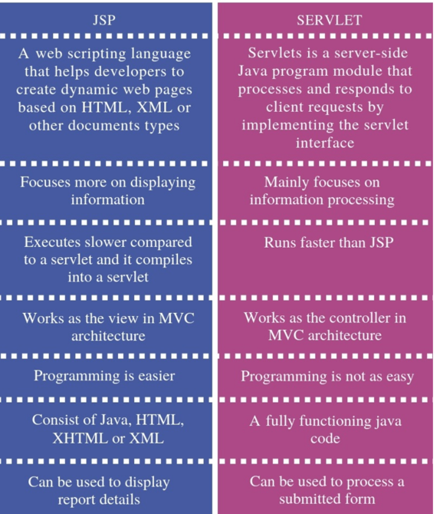

**How many object crated by servlet?**

**=** only one object at time by first request.

**What is Life cycle of servlet?**

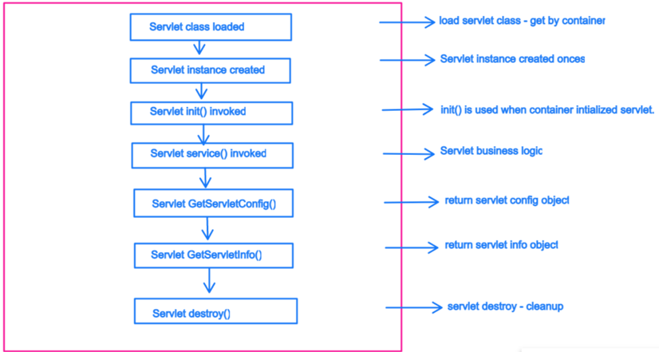

**Who is responsible for create object of servlet?**

* Web container or servlet container

**What is differences of PUT and POST?**

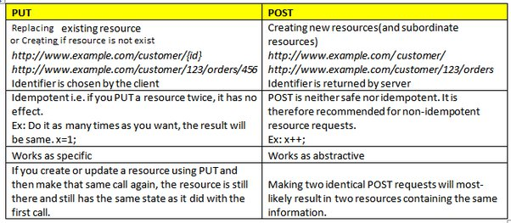

**What is differences of Print Writer and Servlet Output stream**



**What are differences of Servlet, Generic Servlet, Http Servlet**

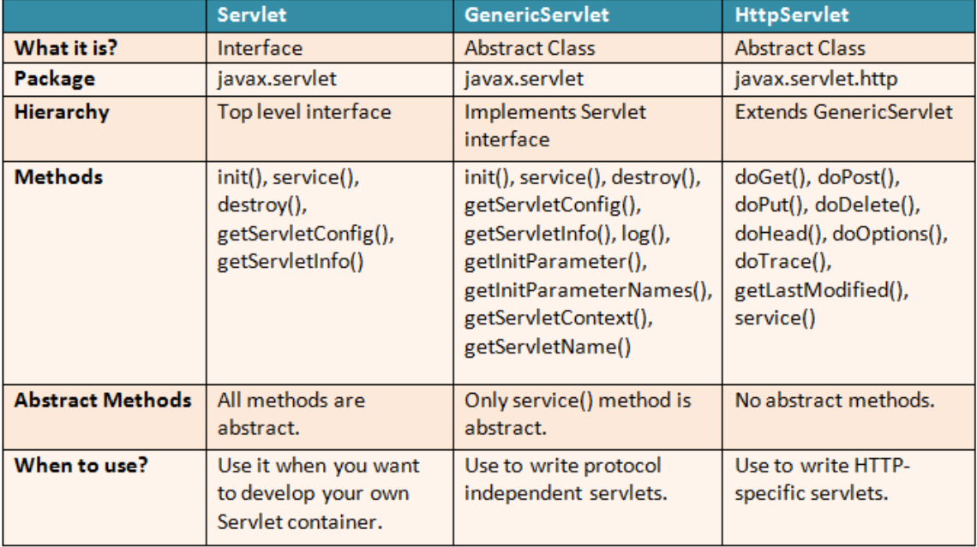

**What is servlet collaboration & Ways?**

* It is used when you need to communicate one servlet to other servlet.
* Request Dispatcher interface = forward() & include()
* Http Servlet Response Interface = sendRedirect()

**What are differences of forward & include method?**

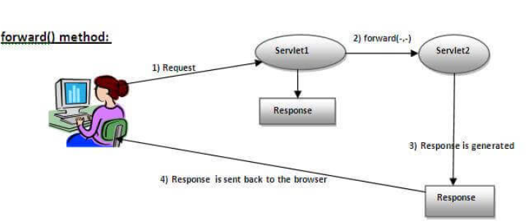



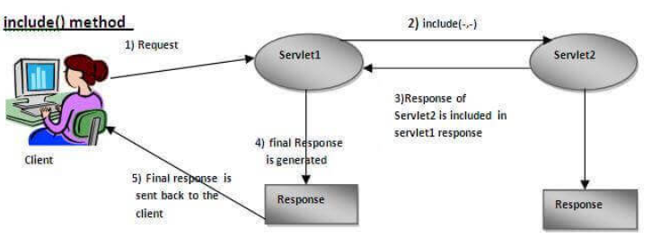



**What are differences of Send Redirect & Forward method**

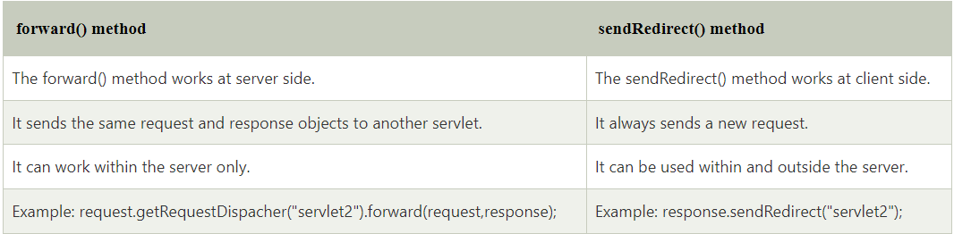

**What is purpose of Request Dispatcher?**

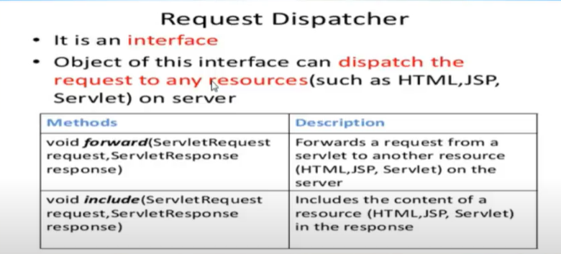

**Can you call JSP from servlet?**

* One way by request dispatcher interface

**What are differences of Servlet Config & Servlet Context?**

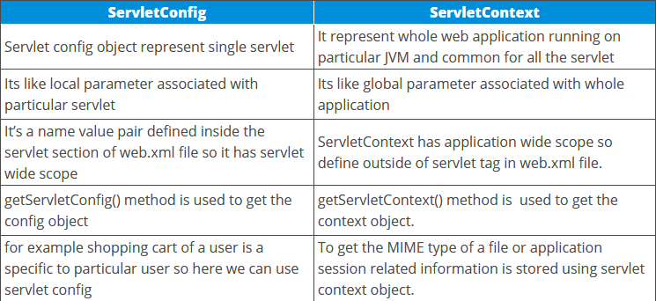

**Servlet Config:**

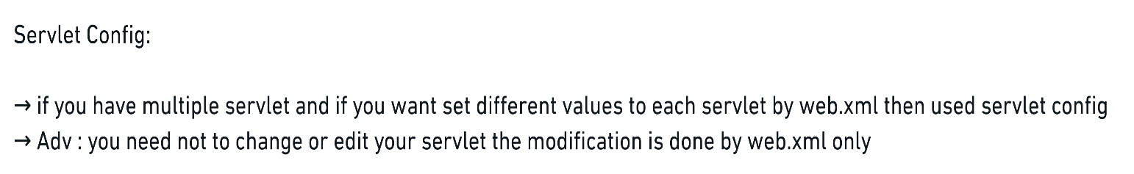

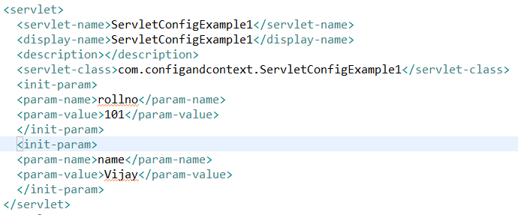

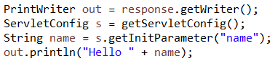

**Servlet Context :**

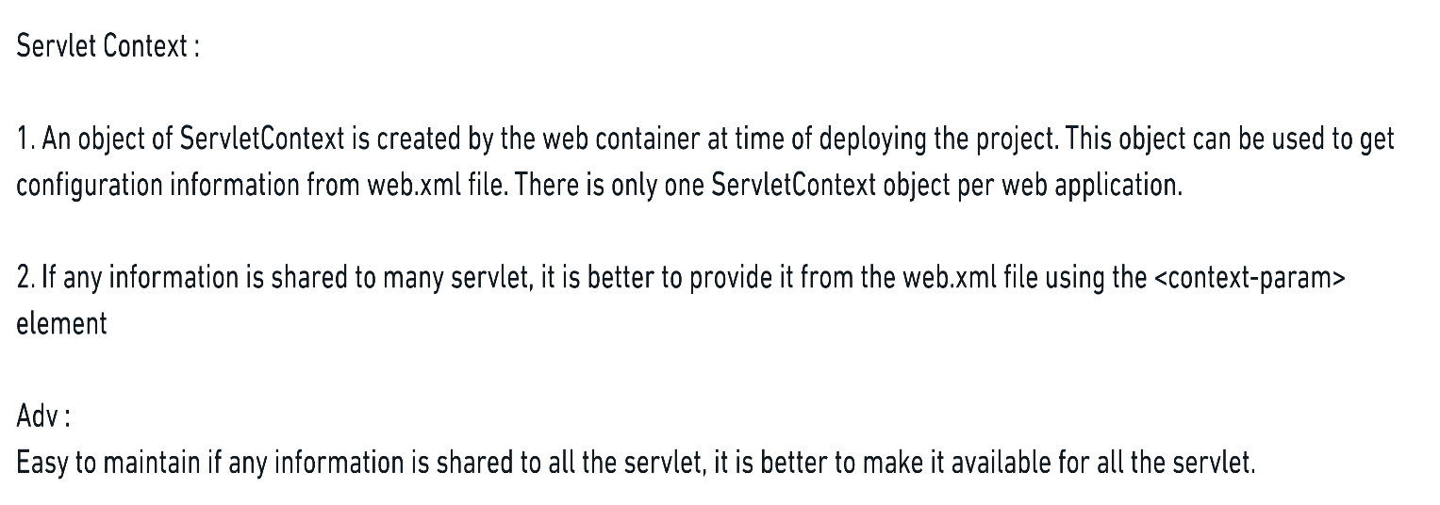

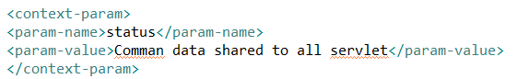

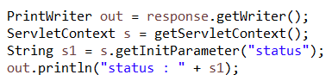

**What is Session Tracking?**

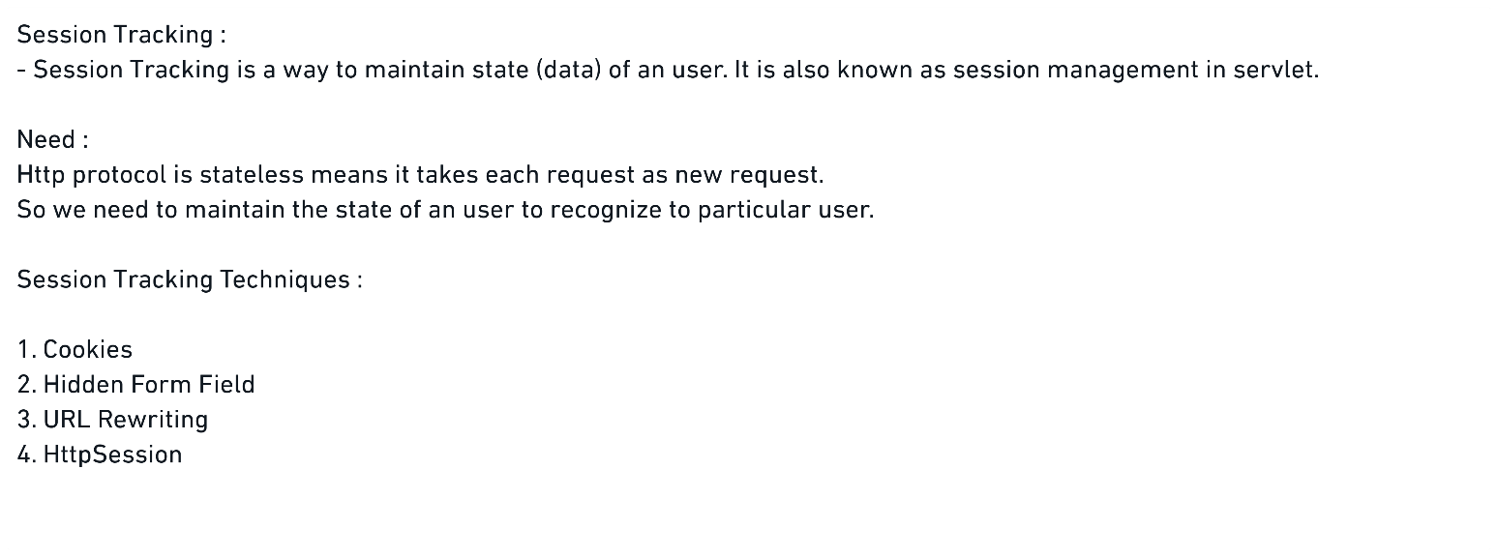

**How Cookies work?**

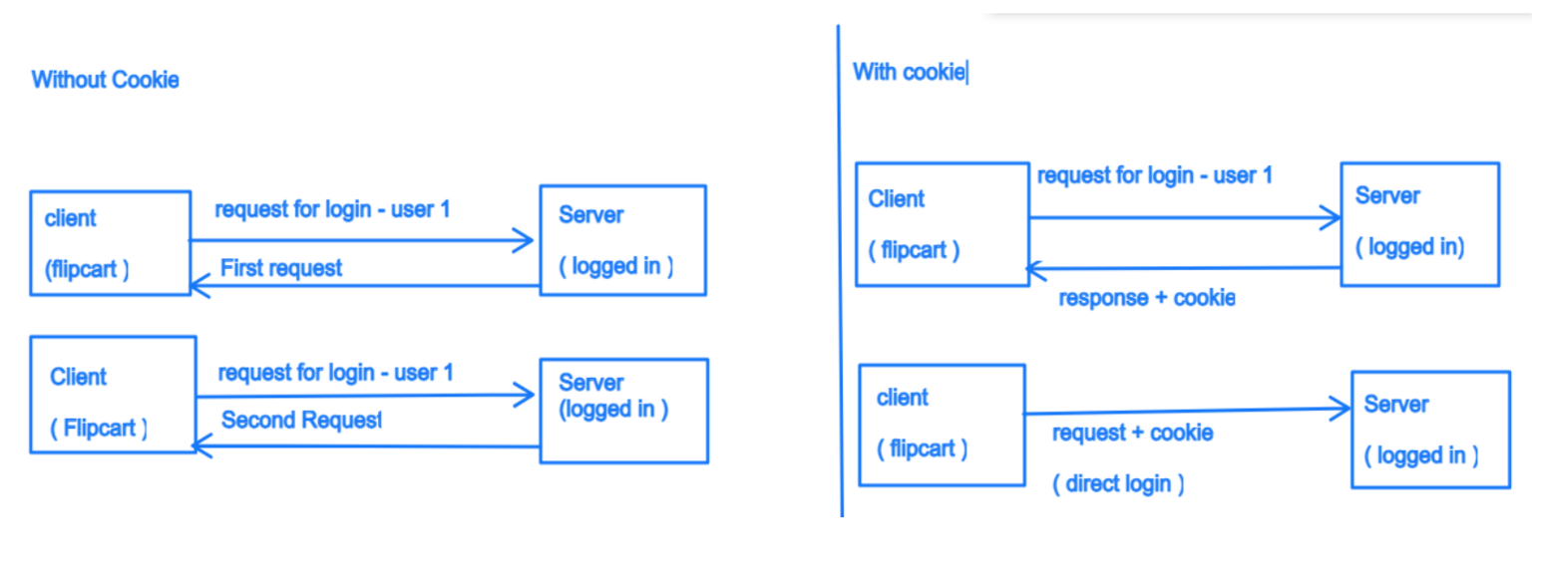

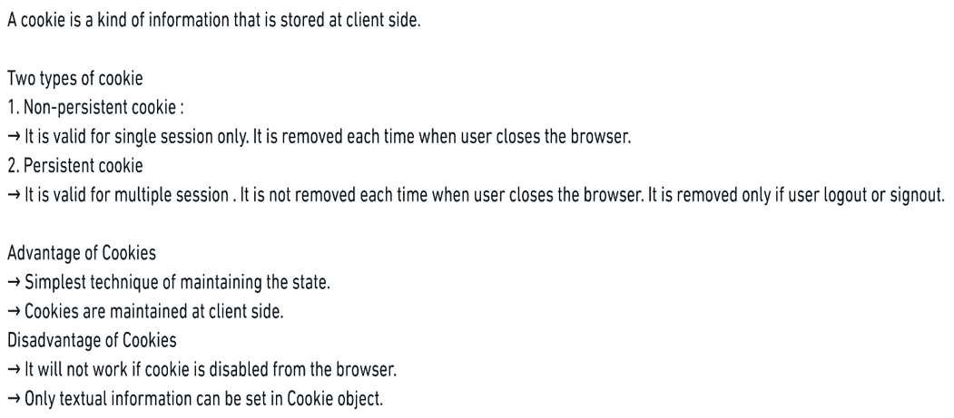

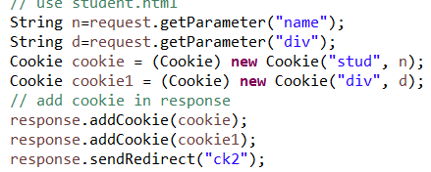

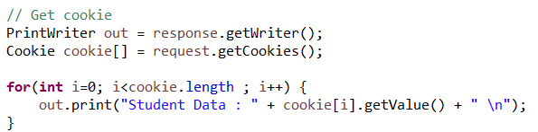

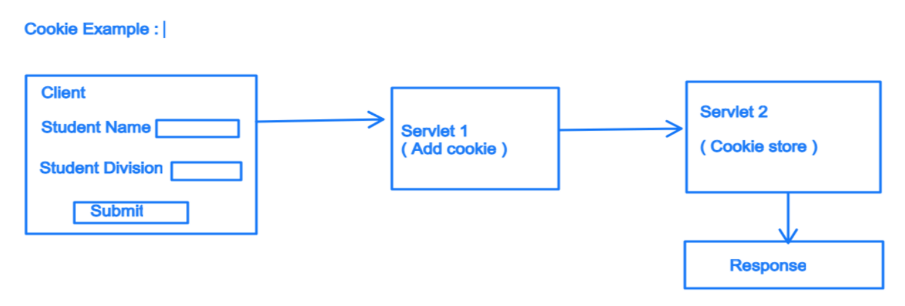

**How Hidden Field works?**

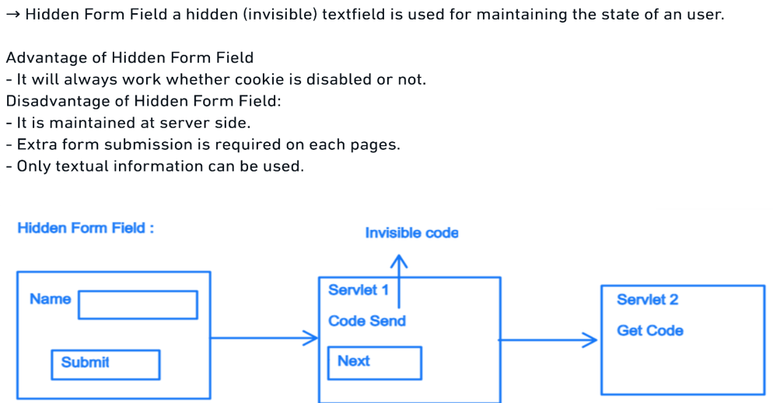

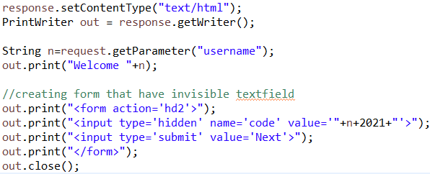

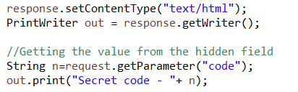

**How URL Rewriting Works?**

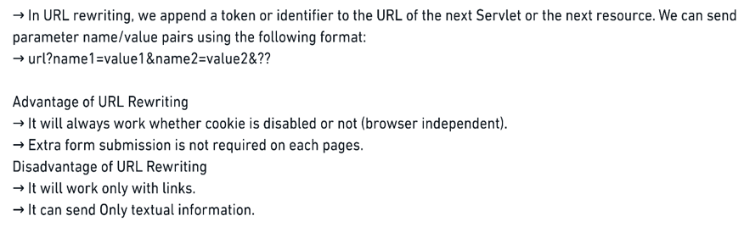

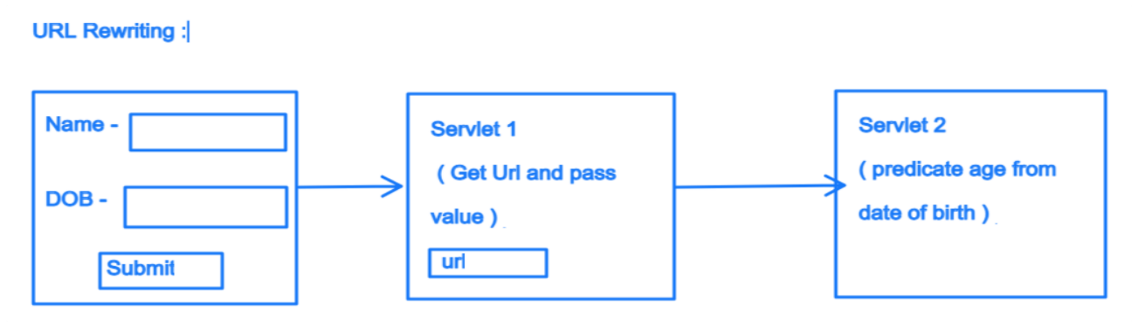

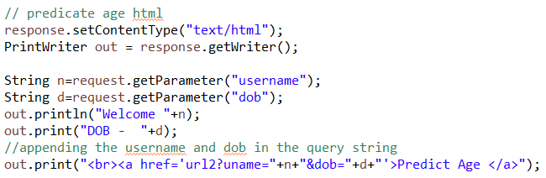

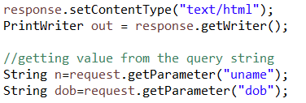

**How HTTP session works?**

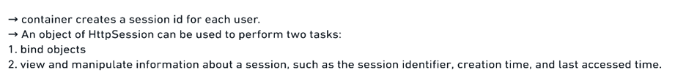

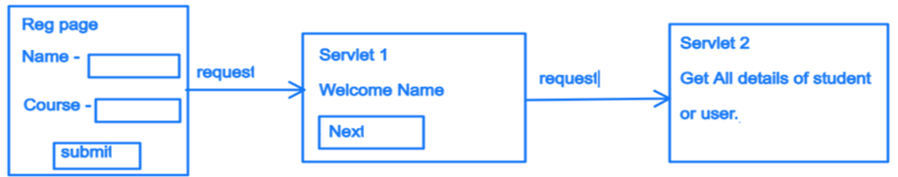

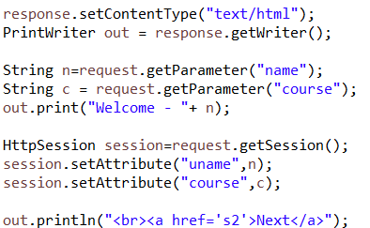

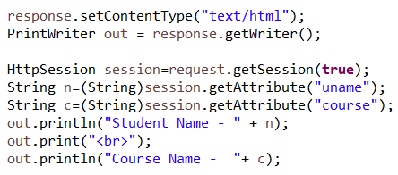

**What is servlet Filter?**

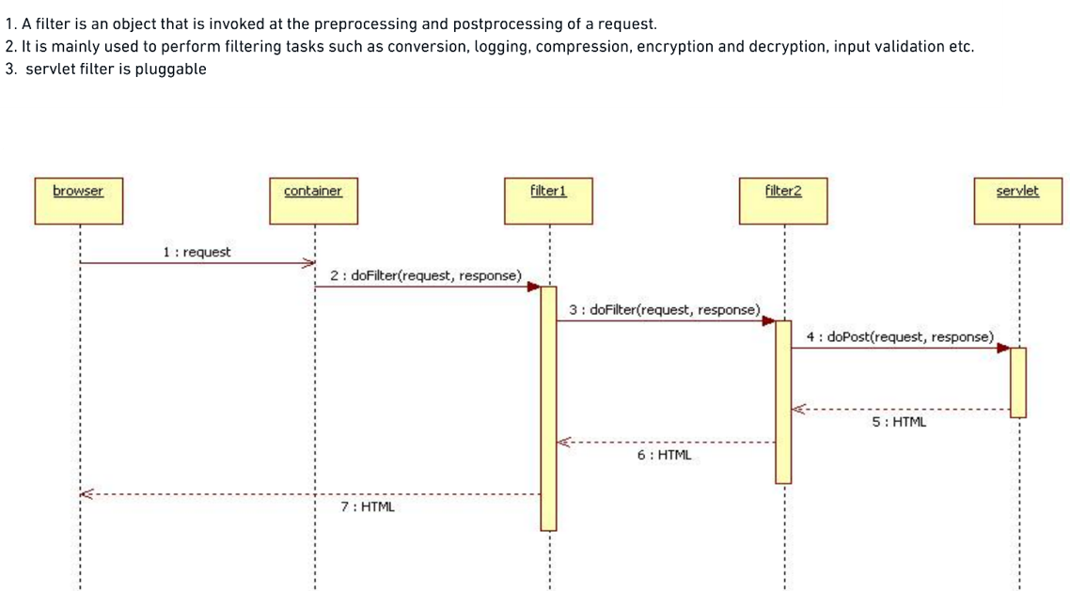

**What are annotations in servlet 3?**

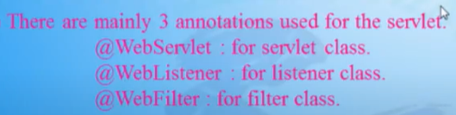

**What CGI and how servlet better than this?**

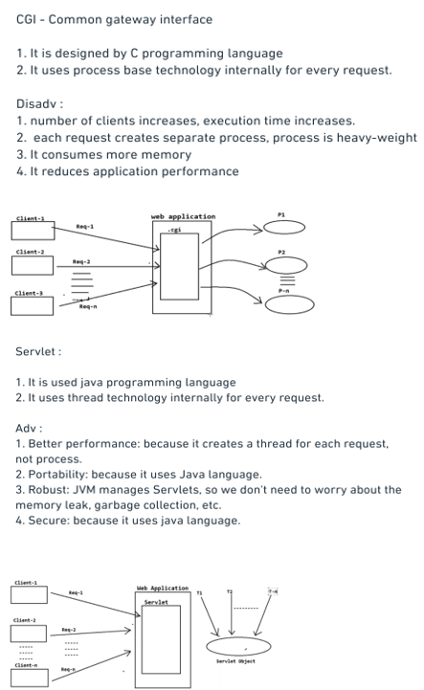

**What is JSP?**

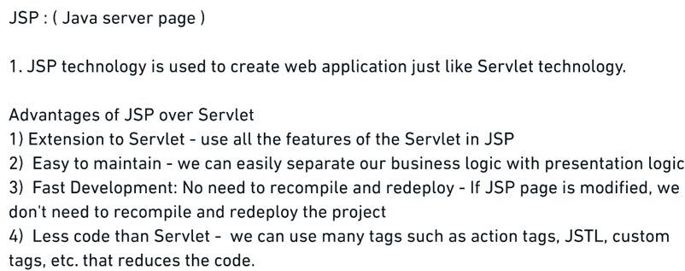

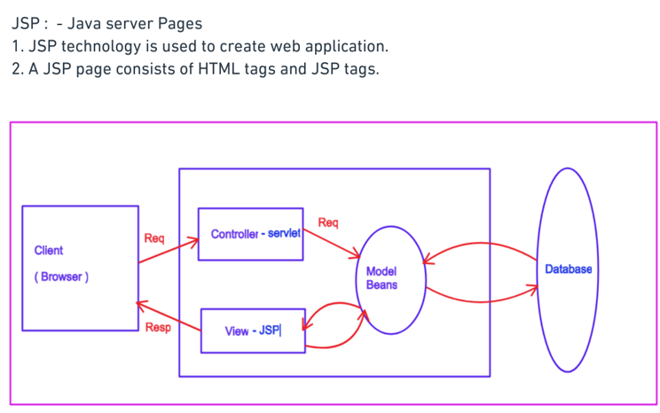

**What are attributes of JSP?**

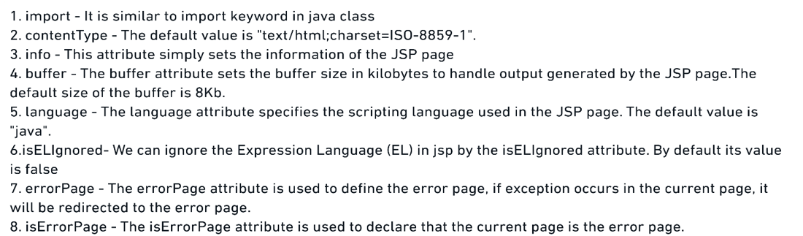

**What is JSTL & Need?**

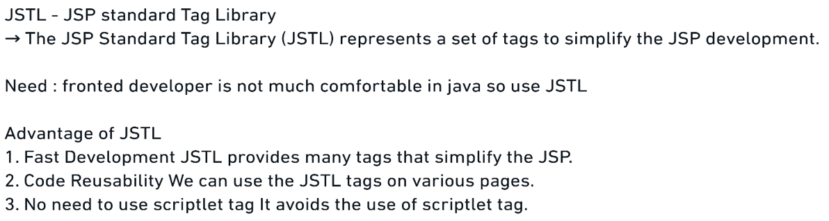

**What are JSTL Tags present?**

